
NextGen 360 Banking-CUSTOMER, CREDIT & Transaction Analytics
Python (Google Collab) & Power BI Desktop

July 7, 2026
Dinesh J
Aspiring Data Analyst
NextGen 360 Banking – Customer, Credit & Transaction Analytics

Project Summary:
- Analyse customer, transaction, and account data to identify customer segments, banking trends, and key factors influencing customer engagement and financial performance.
- Evaluate loan, credit card, and risk-related information to assess lending performance, repayment behaviour, credit utilization, and detect potential fraudulent or anomalous activities.
- Develop an interactive Power BI dashboard that transforms complex banking data into meaningful visual insights, enabling data-driven decision-making and improving operational efficiency.
Tools And Technology Involved:
- Python (Goggle Collab)
- NumPy and Libraries for Data Manipulation
- Matplotlib and Seaborn for Visualization
- Power BI Desktop for interactive dashboards
Python (Goggle Collab):
Data Collection:
- Collected a comprehensive banking dataset from GitHub containing customer demographics, account details, transaction history, loan information, credit card usage, and financial performance metrics moreover it has specification of 5000 rows, 25 columns respectively.
- Validated and prepared the collected data by checking for missing values, duplicate records, and inconsistent data types before performing exploratory data analysis and building interactive Power BI dashboards.
Data Imputation:
- Categorical Column Imputation can be accomplished by “Unknown” in the “Email” categorical column.
- Numerical Column imputation can be accomplished by “Mean” in all nulls in “Account Balance” numerical column.
Data Manipulation:
- “Loan Issue date” column is in Object form is converted into Date format respectively.
- “Full name” column created by concatenating First name and last name columns.
- “Risk Factor” column has created based on the “Anomaly” by the conditions of Risk and No risk criterions respectively.
Visualization:
- Histogram plot defines the distribution of Loan type based on the customer frequency it clearly emphasis that most of the customers holding the Mortgage Loan than others respectively.
- Count Plot defines the distribution of Gender based on the holding accounts it clearly emphasis that Female customers having more accounts in bank which is really a appreciable one.
- Pie Chart emphasises the Unusual or fraudulent transaction report it has been clearly defines 6% of customers done the unusual transaction so the bank has to clearly monitor these accounts to prevent from fraudulent activities respectively.
- Box Plot emphasises the relation between Gender wise account balance analysis it has been observed that the Other category people holding highest account balance of approximately more than 5000 which is more interesting though the female customers where in higher counts.
- Bar Plot describes the average minimum due by card type it has been clearly assumed that Amex Card holders paying higher minimum due which gradually increases bank revenue.
- Violin plot defines the reward points by card type it clearly examines the Master Card type has the highest reward points when compared to others.
- The Scatter plot shows the relationship between Account Balance and Rewards Points, categorized by Gender (Male, Female, Other). The data points are randomly distributed across the plot with no clear upward or downward trend, indicating no strong correlation between account balance and rewards points.
- The Correlation heatmap shows that there is no significant relationship among Age, Rewards Points, and Minimum Payment Due, as all correlation values are very close to 0. This indicates that changes in one variable have little to no impact on the others, suggesting these features are largely independent in the dataset.
- The diagonal histograms in pair plot show that Age, Rewards Points, and Minimum Payment Due are fairly evenly distributed across their respective ranges. The scatter plots in pair plot indicate no strong linear relationship between any pair of variables, as the data points are randomly dispersed.
Power BI Desktop
Import Cleaned Data in Power BI:
- The Cleaned Dataset is extracted from python as a csv file format then it is get imported into Power BI Desktop respectively.
- Transformed the dataset converted the data types for currency related columns to fixed decimal format respectively.

Interactive Dashboard 1:
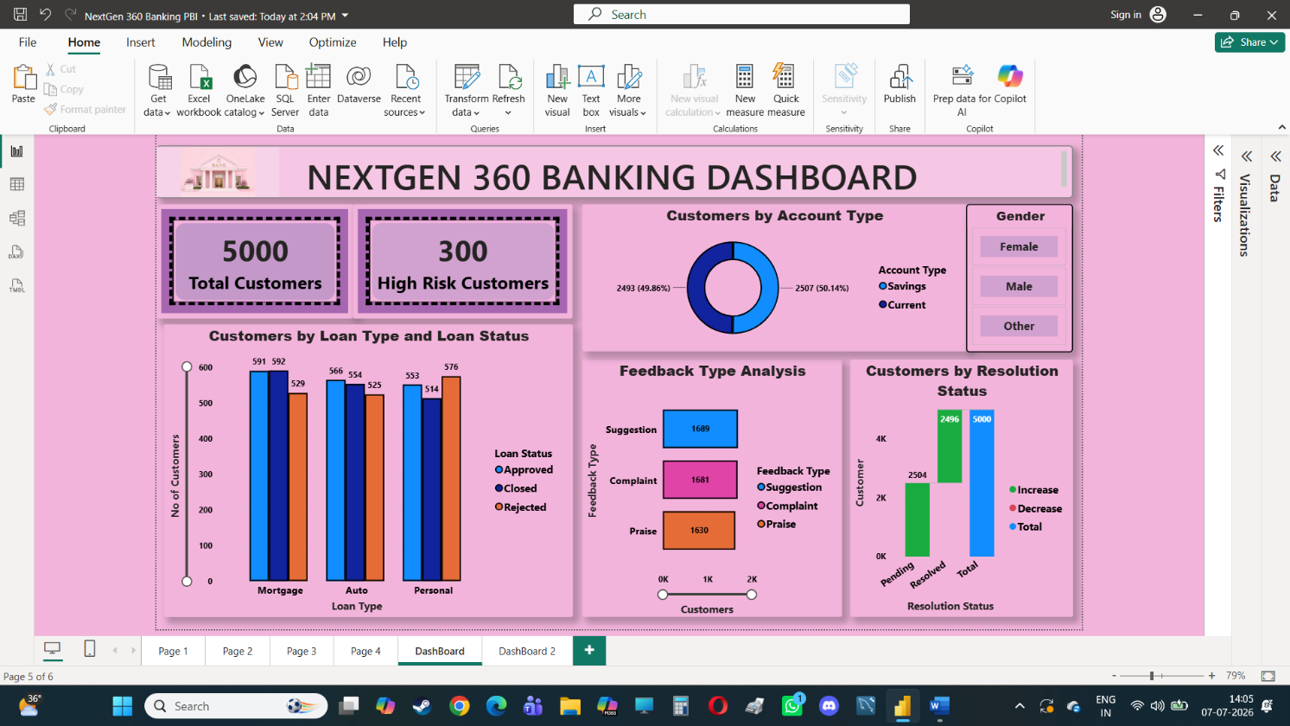

Insights from Dashboard 1:
- The bank serves 5,000 customers, with only 300 (6%) classified as high-risk, indicating a stable and healthy customer portfolio meanwhile it emphasises strong customer base with low risk respectively.
- The Resolution status emphasis Pending status has a higher number than the resolved so bank should look on to customer feedback and rectify the issues respectively.
- Customers are almost equally divided between Savings (50.14%) and Current (49.86%) accounts, showing balanced usage of banking services. Obviously, it demonstrates Balanced account distribution.
- Mortgage and Auto loans have high approval and closure rates, while Personal Loans record the highest number of rejections (576), suggesting stricter eligibility criteria or higher applicant risk.
- Feedback is nearly balanced across Suggestions (1,689), Complaints (1,681), and Praise (1,630), indicating active customer engagement however the bank should focus to reduce complaint as possible as lower respectively.
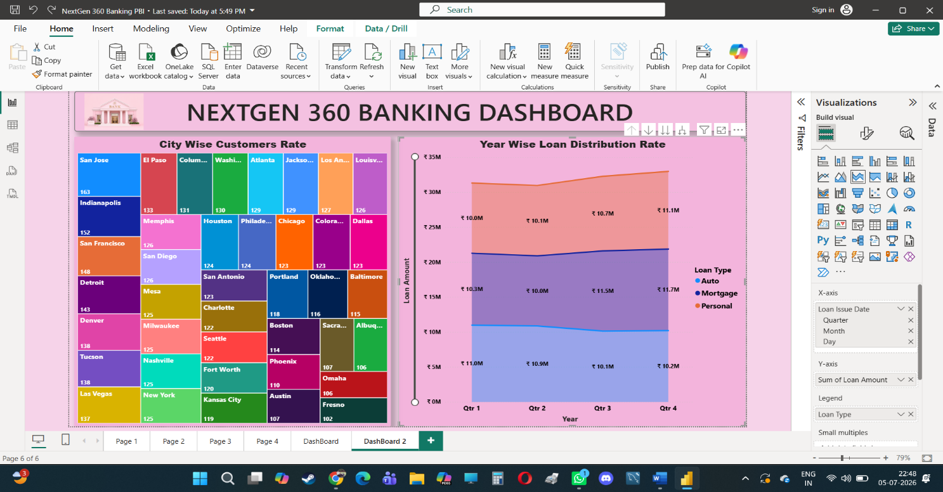
Interactive Dashboard 2:
Insights from Dashboard 2:
- The total loan amount shows a steady increase from Q1 to Q4, with Q4 recording the highest loan disbursement, indicating improved lending performance and growing customer demand throughout the year.
- Mortgage and Personal Loans contribute the largest share of the total loan amount across all quarters, while Auto Loans remain relatively stable, suggesting stronger customer preference for long-term financing products.
- San Jose has the highest customer count (163), followed by Indianapolis (152) and San Francisco (148). This indicates these cities represent the bank's strongest customer markets and offer significant opportunities for business growth and targeted marketing initiatives.
Final Summary & Business Recommendations:
- The bank serves 5,000 customers, with only 6% classified as high-risk, indicating effective customer management and a healthy banking portfolio.
- Savings and Current accounts are almost equally distributed, demonstrating balanced customer preference across major banking products.
- Mortgage loan plays majority basically it’s a long-term loan with, moderate interest rate illustrates like “A Duck laying a golden egg everyday” in order to that it gradually boosts bank revenue drastically.
- Personal loans show the highest rejection rate maybe reason of improper documentation and poor CIBIL score, suggesting opportunities to refine credit assessment models or introduce customized loan products like Micro personal loan for eligible customers.
- From the analysis Master Card users has gained a higher reward points in order to utilize a marketing strategy deploy like pop up gadgets advertisements, house hold utensils products etc through net banking portals and text messages in order to redemption those reward points respectively.
- Quarterly loan analysis indicates increasing loan amounts throughout the year, with Q4 recording the highest lending activity, reflecting business growth and stronger customer demand.
- As per the Sentimental analysis Suggestions feedback slightly exceed of complaints and praise, indicating customers are actively engaged and providing constructive feedback that can improve banking services and customer experience and analysing the resolution status it has higher numbers in pending status. Moreover, the bank should discuss with CRM Team in order to focus on complaint rates and pending resolution status and try to reduce as lower numbers as possible.
- Cities such as San Jose, Indianapolis, and San Francisco have the highest customer counts, making them strategic locations for expanding banking services and marketing initiatives.
Future Scope:
- Integrate Machine Learning models to predict loan defaults, customer churn, and high-risk customers, enabling proactive decision-making.
- Enhancing customer analytics involves analysing customer demographics, transaction history, loan behaviour, and feedback to better understand customer needs and preferences.
- By using these insights, the bank can segment customers into different groups (such as high-value, frequent borrowers, or high-risk customers) and offer personalized products, targeted marketing campaigns, and customized financial services.

